Round Towers Clondalkin, Good Counsel, Westmantown
&
St Pats Palmerstown GAA

Advanced Performance Coaching
U-13 – U-16 Boys & Girls
Date Venue Time
Tues 29th Oct: Round Towers Clondalkin GAA Club (Football) 11am-2.30pm
Wed 30th Oct: Good Counsel GAA Club (Hurling & Camogie) 11am-2.30pm
Thurs: 31st Oct Westmanstown GAA Club (Physical & Lifestyle) 11am-2.30pm
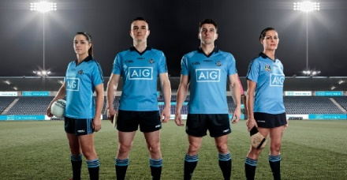
Total Cost: €50
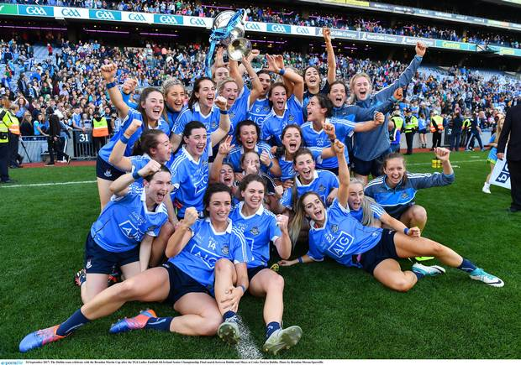
Special Guest Coaches Include Inter County Players
High Performance Coaching County Stars For Coaches Fun & Enjoyment
Health & Wellbeing Session Covering All Codes Improve Your Performance
Bring A Packed Lunch And Water Bottle
Players Name: ………………………………………………………………………………………………………….
Age: …………………………………………………………………………………………………………………………
Date of birth: …………………………………………………………………………………………………………..
Name of Parent/Guardian: ……………………………………………………………………………………….
Parent/Guardian Contact Number: ………………………………………………………………………….
Any Medical conditions :…………………………………………………………………………………………..

